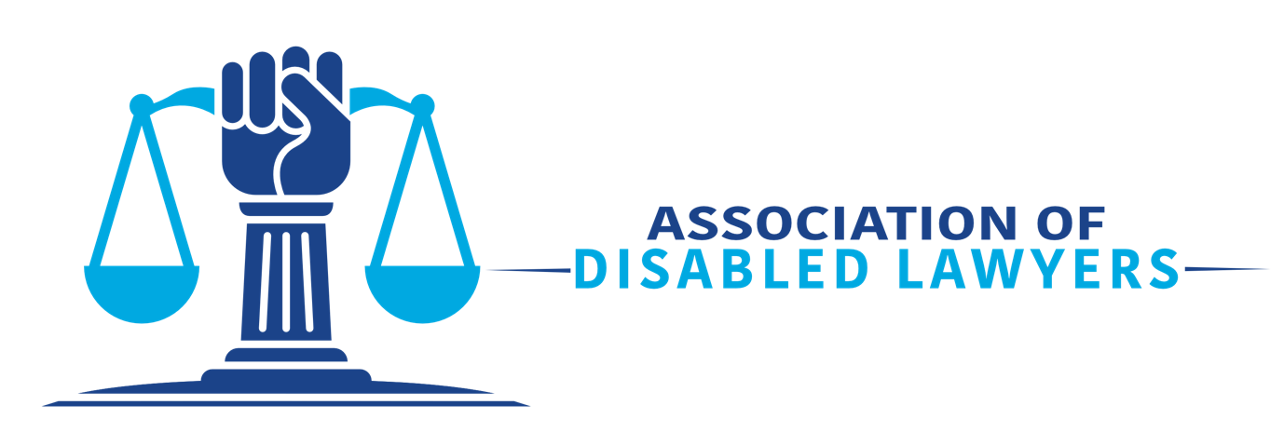
Communications and Marketing Coordinator Role Description
About the Association of Disabled Lawyers

The Association of Disabled Lawyers (“the Association”) leads the way in creating an inclusive legal profession, with a primary focus on disabled lawyers and students and lawyers and students with long-term physical, mental, and learning conditions. * We exist to forge a community and network for disabled lawyers and law students. We make it known that you can practice law and be a disabled person. We are a platform for sharing ideas for positive change to the many obstacles that make entering the legal professions and maintaining a career difficult. We also collaborate with other organisations that have similar objectives. We, as disabled people, promote the rights of all disabled people.

*We paraphrase this as “disability” or “disabled”, but we respect your decision whether to identify as disabled.
The Communications and Marketing Coordinator will be responsible for the following:
- Designing and maintaining a Social Media Strategy for developing the organisation’s online presence;

- Developing and maintaining a Style and Conduct Guide ensuring consistent and appropriate communications;

- The promotion and reputation of the organisation across all social media channels;

- Keeping up to date with emerging and established legal and disability trends and competitor activity and continuously seeking out new creative opportunities;

- Creating and distributing weekly content for the organisation’s social media platforms and monthly and ensuring content is engaging and tone of voice is in line with the Style and Conduct Guide;

- Overseeing the day-to-day management of multiple channels and, where possible, taking a proactive approach.

- Working with the Chair to create email marketing materials.

- Identifying content that may be used on the organisation’s website and liaising with other volunteers to create news articles and maintain an excellent overall presentation of the Association; and

- Attending relevant meetings.

Time Commitment: 5 hours per week.

How to Apply and Reasonable Adjustments

We invite applicants to send a curriculum vitae and cover letter to admin@disabledlawyers.co.uk by 1st January 2024. The Association’s team will then review the submissions and ask a selection of candidates to talk with us, either online or in person, to discuss the Association and role.

We strongly encourage people from non-white backgrounds to apply.

Please let us know if the process or role could be adjusted to enable you to demonstrate your skills and potential best, and we will endeavour to facilitate any proposed changes. If you are unsure of the adjustments needed, please get in touch with us, and we will work with you to find a solution. Our email address is admin@disabledlawyers.co.uk.

