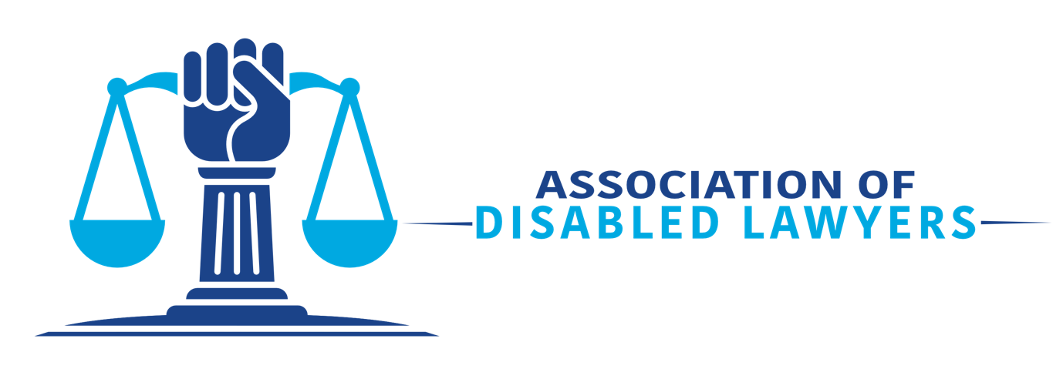
Social Media Volunteer Role Description
About the Association of Disabled Lawyers

The Association of Disabled Lawyers (“the Association”) leads the way in creating an inclusive legal profession, with a primary focus on disabled lawyers and students and lawyers and students with long-term physical, mental, and learning conditions. * We exist to forge a community and network for disabled lawyers and law students. We make it known that you can practice law and be a disabled person. We are a platform for sharing ideas for positive change to the many obstacles that make entering the legal professions and maintaining a career difficult. We also collaborate with other organisations that have similar objectives. We, as disabled people, promote the rights of all disabled people.

*We paraphrase this as “disability” or “disabled”, but we respect your decision whether to identify as disabled.

The Social Media Volunteer will be responsible for the following:
- The promotion and reputation of the organisation on a social media channel;

- Keeping up to date with emerging and established legal and disability trends and competitor activity and continuously seeking out new creative opportunities;

- Overseeing the day-to-day management of a channel and, where possible, taking a proactive approach.

- Working with the Communication and Marketing Coordinator to create email marketing materials.

- Identifying content that may be used on the organisation’s website and liaising with other volunteers to create news articles and maintain an excellent overall presentation of the Association; and

- Attending relevant meetings.

Time Commitment: 5 hours per week.

How to Apply and Reasonable Adjustments

We invite applicants to send a curriculum vitae and cover letter to admin@disabledlawyers.co.uk by 1st January 2024. The Association’s team will then review the submissions and ask a selection of candidates to talk with us, either online or in person, to discuss the Association and role.

We strongly encourage people from non-white backgrounds to apply.

Please let us know if the process or role could be adjusted to enable you to demonstrate your skills and potential best, and we will endeavour to facilitate any proposed changes. If you are unsure of the adjustments needed, please get in touch with us, and we will work with you to find a solution. Our email address is admin@disabledlawyers.co.uk.

