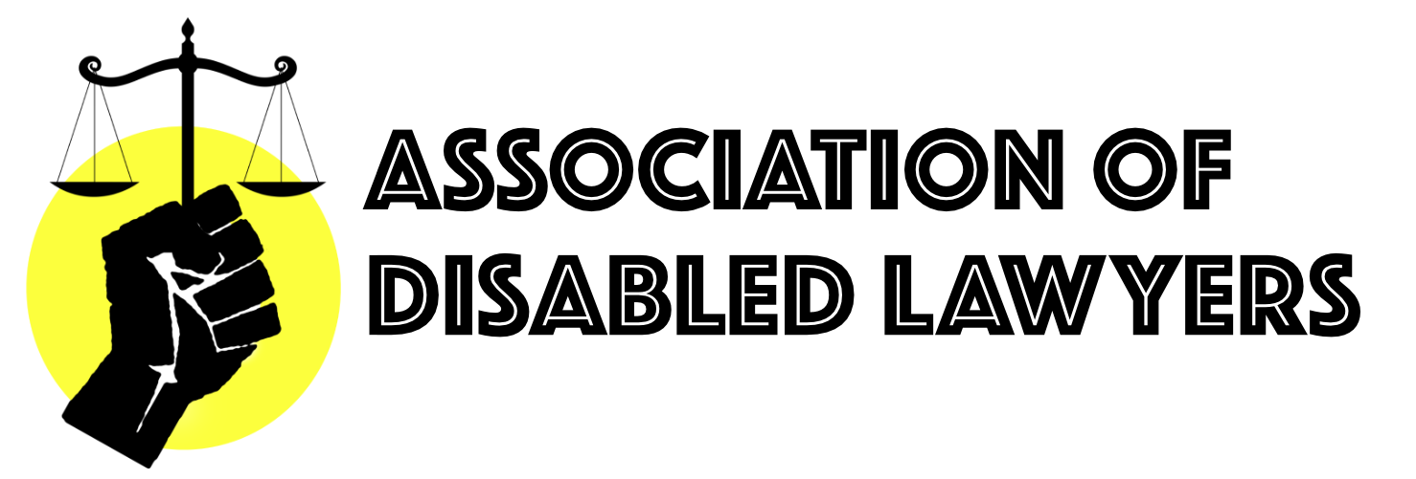

Association of Disabled Lawyers Statement Regarding the August 2020 BSB Examinations – 27th July 2020

The COVID-19 pandemic has created unprecedented and unexpected challenges. The members of the Association of Disabled Lawyers (‘the Association’ hereafter) have intimate experiences of the hardships resulting from the coronavirus crisis. Disabled people and people with health conditions have endured shielding, increased hostility and isolation, difficult working conditions and complex personal circumstances. We, therefore, appreciate the complications caused by the pandemic.

The Association is, nevertheless, troubled and disheartened with the handling of Bar Professional Training Course (‘BPTC’) students sitting the centralised exams in August. We are deeply concerned that these adverse measures undermine equality and diversity efforts at the Bar. Disabled students and students with health conditions have been disadvantaged and left behind.

On 13th May, the Bar Standards Board (‘BSB’) announced its decision to assess the majority of students using remotely proctored examinations. They also require access to quiet spaces, a strong internet connection, and a device that can support live video monitoring. Students unable to use this system, and those with reasonable adjustments beyond minimal extra time and scheduled breaks, were expected to access Pearson VUE test centres to complete the examinations. Test centres, however, have limited capacity to make adjustments. On 14th May, our Chair, Daniel Holt, contacted the BSB’s Equality and Diversity team to highlight how both options will cause unfairness and disadvantage. Daniel was informed that its Examinations Team was working with BPTC providers to implement students’ reasonable adjustments.

Students Against the Bar Exams Regulations (‘SABER’) wrote to the BSB on 1st June emphasising the discriminatory nature of the arrangements and proposing an open book examination that would reduce the unfairness and disadvantage caused by Pearson Vue’s practices. The BSB responded with assurances that all reasonable adjustments would be made (15th June) and “no student should be asked to waive a reasonable adjustment” (3rd July). BPTC providers were awaiting communication from the BSB in mid-July, despite these declarations and those given to Daniel in May. Many students have been offered slots in centres far from their home and/or very early in the morning.

Students with reasonable adjustments were supposed to be able to book their slots at test centres before students without adjustments. On 20th July, test centre bookings opened to students without adjustments and the difficulties have continued. Limited test centre availability has meant that students without a stable internet connection or quiet space are forced to sit the examinations online and risk being disqualified since noise and background activity can automatically terminate the examination.

The poor handling of the examinations has put disabled students and students with health conditions under significant stress and disadvantage. Students have experienced disorganised booking systems and processes. Many students have had to defer their examinations until December because their reasonable adjustments could not be appropriately implemented. Others are sitting the examinations without their adjustments or with inappropriate measures. One reason for this is that the process has been too stressful. Secondly, some students need to begin employment/pupillage. Thirdly, visas have already expired or will expire before the deferred examinations. Furthermore, revision time has been severely restricted for many students because of organising examinations and suffering exacerbated symptoms.

These examinations in August are not a fair assessment of students’ abilities. The Association, therefore, recommends that:

- The BSB accommodates students and investigates its failings and the impact on students. It should publish a public report of its findings.

- The difficulties faced by students are factored into their examination marks;

- All students are allowed to resit examinations without penalty in December, to reflect the difficult circumstances under which the August examinations are being taken, and time lost during the revision period is taken into consideration.

- Chambers’ pupillage committees waive requirements for incoming pupils to achieve a specific BPTC grade, and disregard the grades of prospective candidates in the next application round;

- Compensation is awarded to students for costs incurred in travelling to test centres, booking fees, and in calling international hotlines; and

- The results of deferred examinations in December 2020 be published before Pupillage Gateway closes.

Association of Disabled Lawyers

